Task on EC2
1.Launch one EC2 using Amazon Linux 2 image and add a script in user data to install Apache.
- Logged in to Amazon Web Services Console, opened EC2 Dashboard, clicked Launch Instance, and entered the name as Apache-Server.
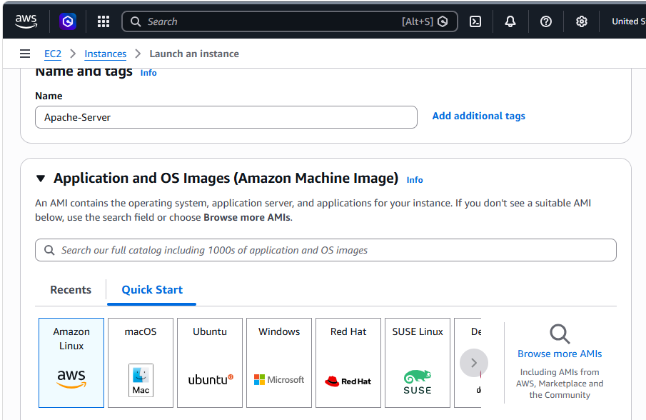
- Added the user data script to update the system, install Apache (httpd), start the service, and enable it during instance launch.
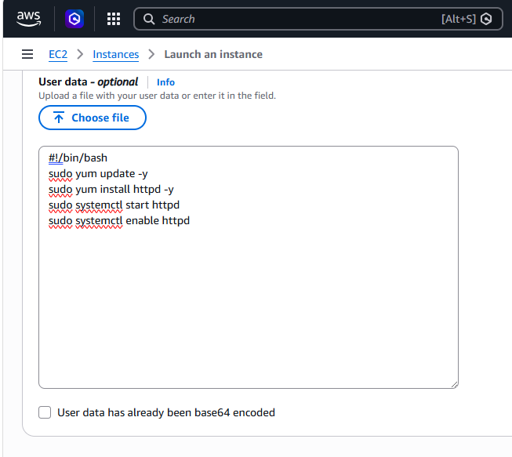
- Copied the EC2 instance public IP, opened it in the browser, and verified that the Apache web server page was displayed successfully.
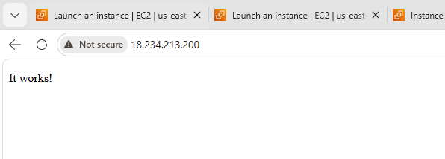
2.Launch one EC2 using Ubuntu image and add a script in user data to install Nginx.
- Logged in to Amazon Web Services Console, opened EC2 Dashboard, clicked Launch Instance, and entered the name as Nginx-server.
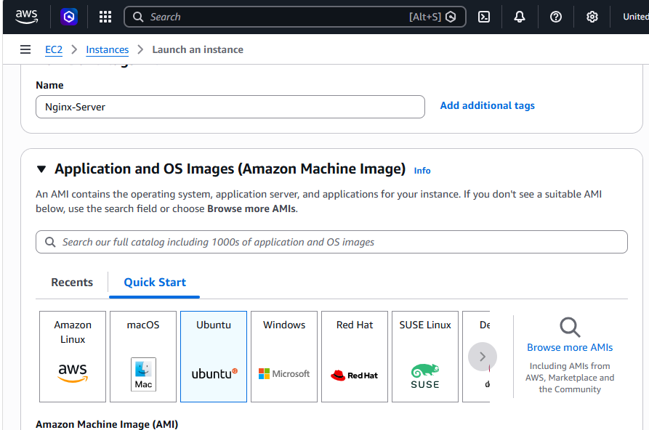
- Added the user data script to update the system, install Nginx, start the service, and enable it during instance launch.
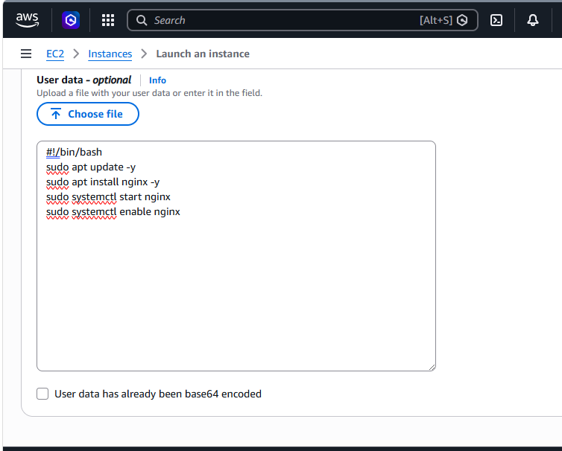
- Copied the EC2 instance public IP, opened it in the browser, and verified that the Nginx web server page was displayed successfully.
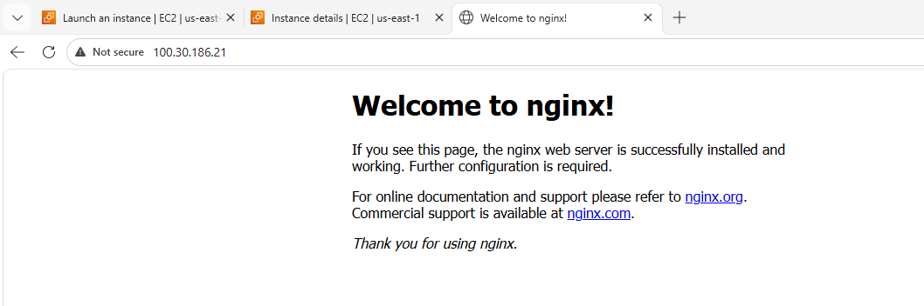
3.Launch one Windows server and install Tomcat on Windows.
- Clicked Launch Instance, entered the name as windows tomcat-sever, and selected the Windows AMI.
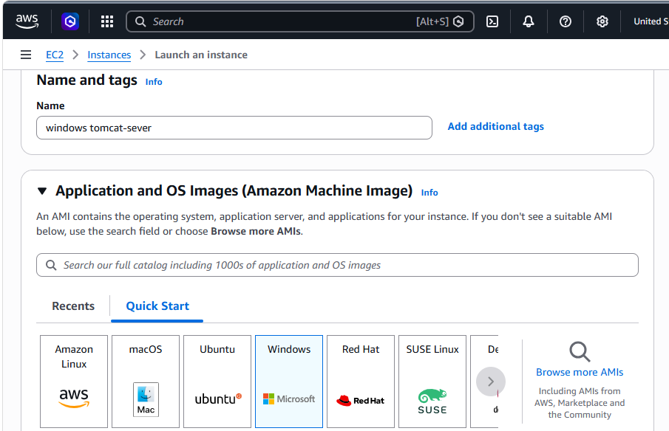
- Connected to the Windows EC2 instance successfully using Remote Desktop (RDP).
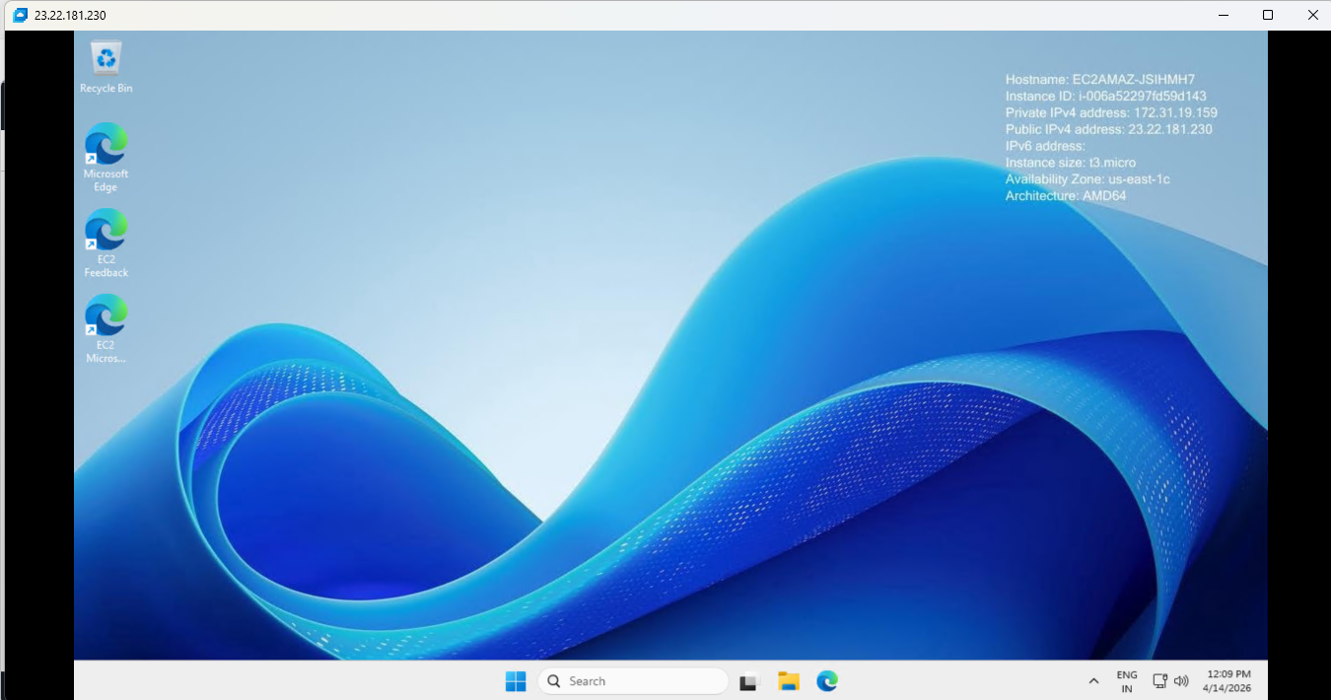
- Configured the JAVA_HOME environment variable by setting the JDK installation path on the Windows server.
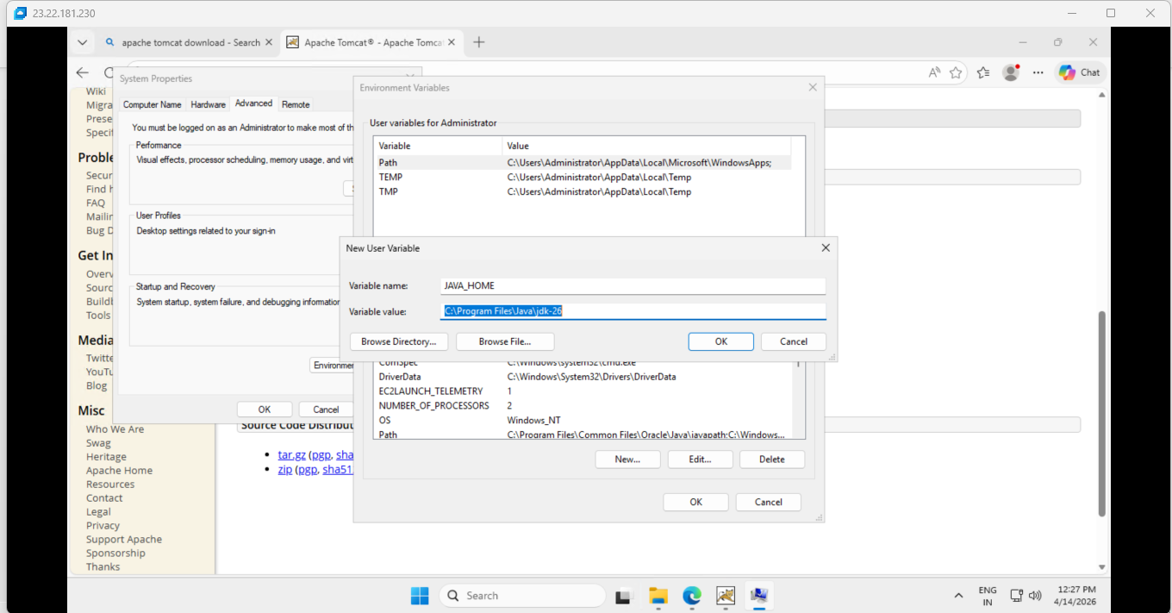
- Started Apache Tomcat on the Windows server and verified the Tomcat default page was displayed successfully in the browser.
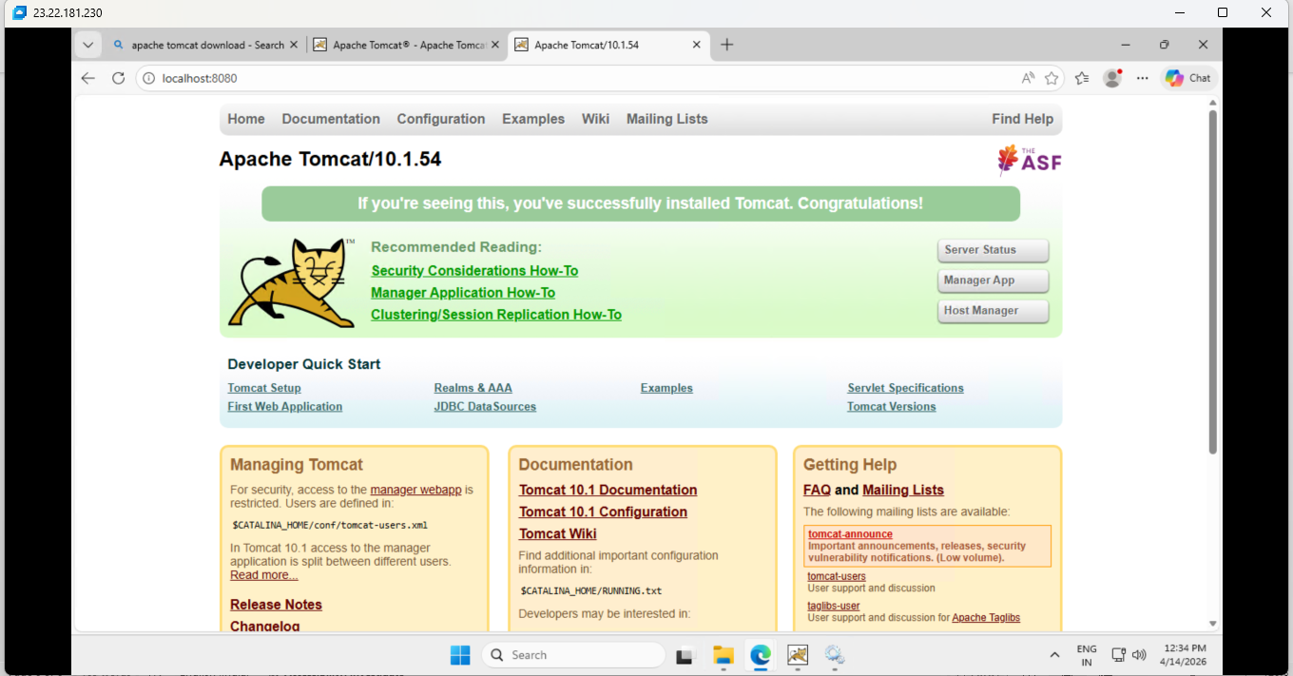
4.Take a snapshot of the instance created in Task 1
- Opened the Create Snapshot page, selected the Apache-Server instance as the source, and proceeded to create the snapshot.
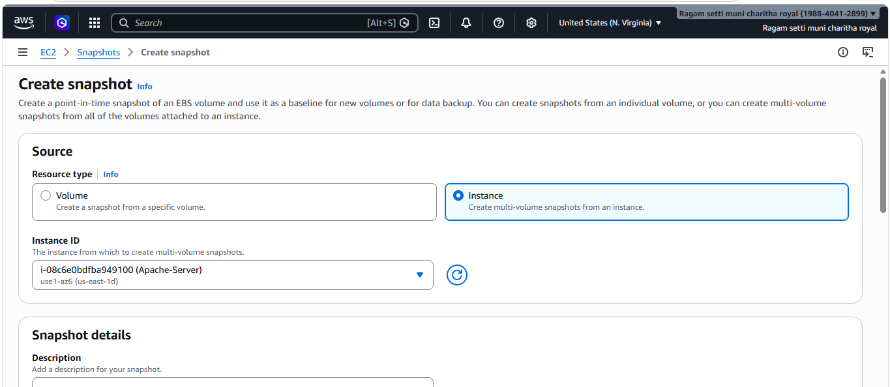
- Verified in the Snapshots section that the snapshot was created successfully with completed status.
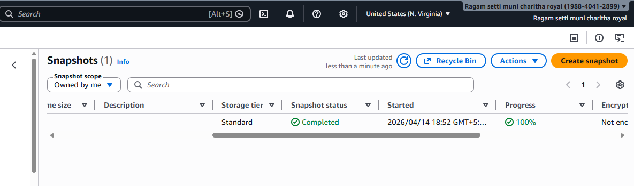
5.Assign passwordless authentication for the EC2 created in Task 2.
- Generated the SSH key pair using ssh-keygen, viewed the public key, and prepared to configure passwordless authentication for the EC2 instance.
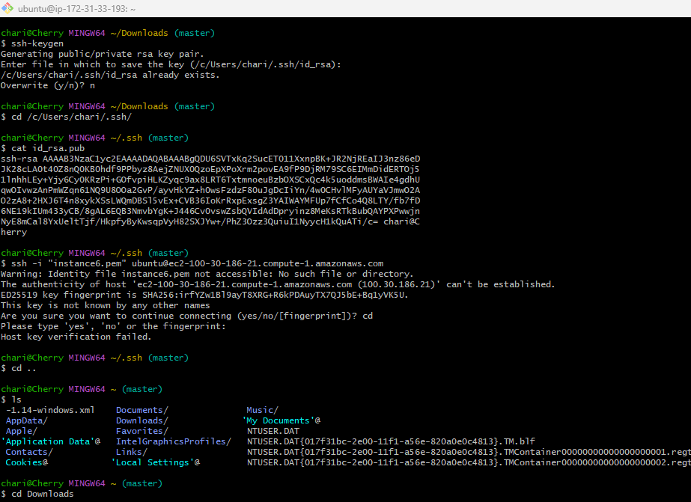
- Connected to the Ubuntu EC2 instance, added the public key to the authorized_keys file, set the required permissions, and exited successfully.
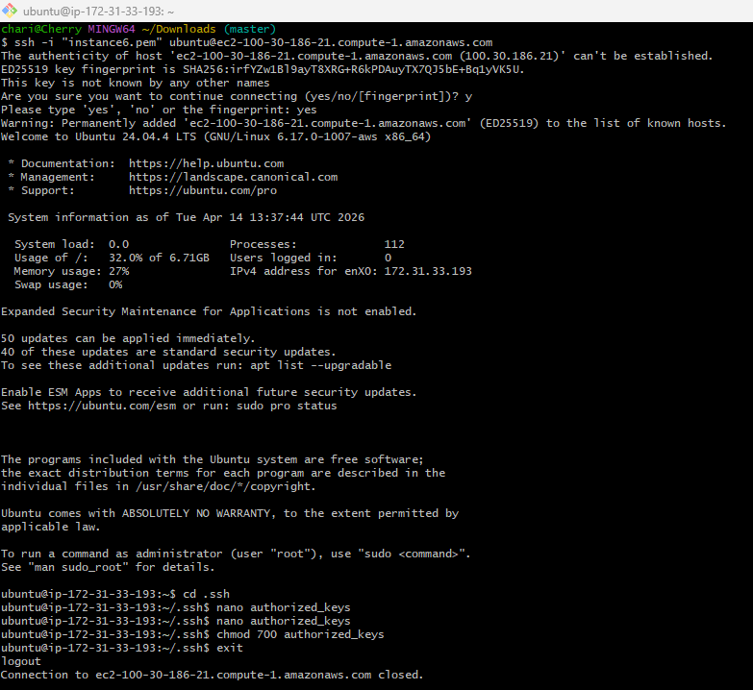
- Verified passwordless authentication by connecting to the Ubuntu EC2 instance successfully using SSH.
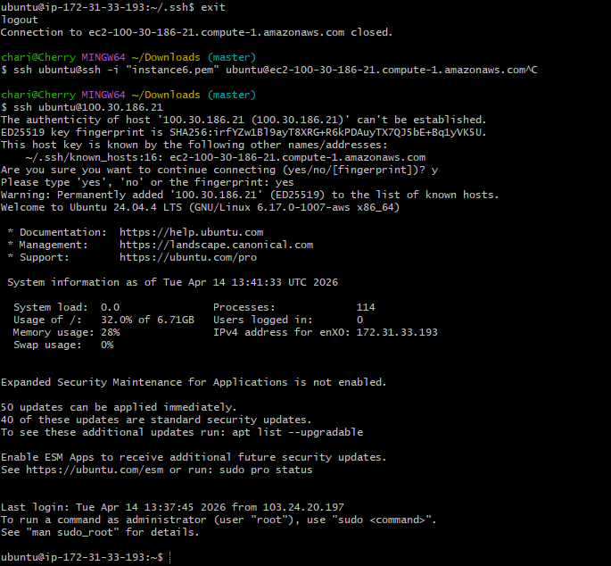
6.Launch any EC2 using the spot purchasing option.
- Selected the Spot purchasing option, configured the maximum price and request settings, and proceeded to launch the EC2 instance successfully.
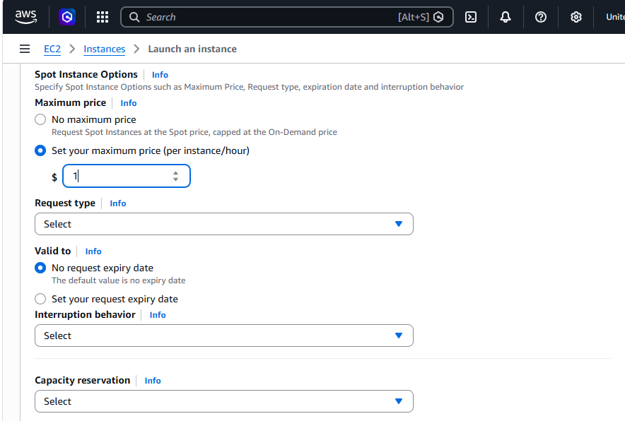
- Verified in the Spot Requests section that the Spot EC2 instance request was active and fulfilled successfully.
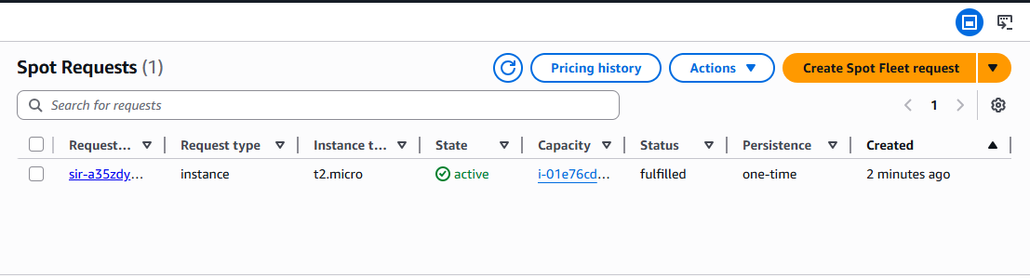
7.Enable termination policy on the EC2 created in Task.
- Opened the termination protection settings for the Nginx-Server instance, enabled the option, and saved the changes successfully.
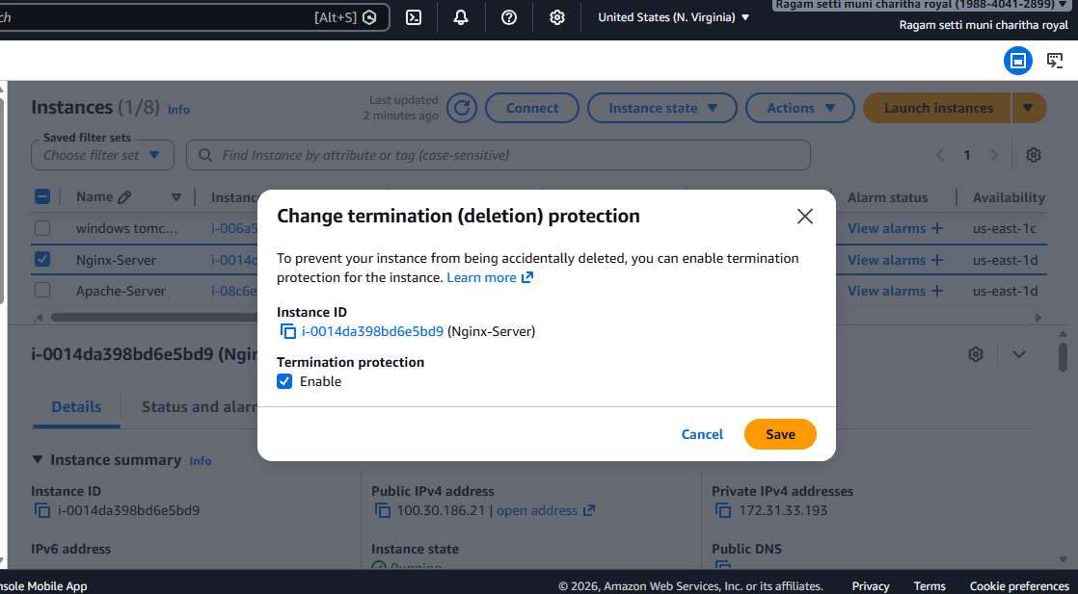
8.Launch one EC2 using AWS CLI.
msiexec.exe /i https://awscli.amazonaws.com/AWSCLIV2.msi
msiexec.exe /i https://awscli.amazonaws.com/AWSCLIV2.msi /qn
aws --version
